09-06 - Variables

# 1. Retrieval

* What are programs? What are computations? What are algorithms?
* What is code?
* What is a programming language?
* Why it can be hard to use a programming language?

# 2. Thonny IDE (POGIL, 15 min)

Thonny is an integrated development environment (IDE) for Python designed for learning and teaching programming. It is freely available at <https://thonny.org/>.

**Do not run Thonny yet! Answer the questions first!**

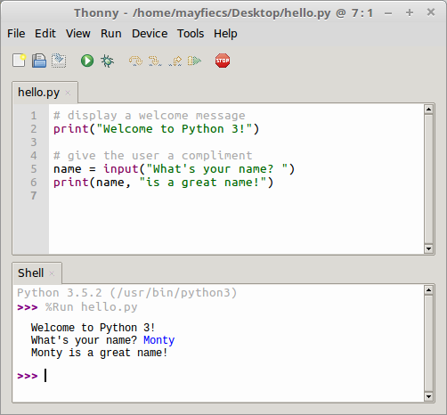

Thonny

Based on the screenshot:

1. Where is the *Shell* window?
2. Where is the *Editor* window?
3. What is the name of the file in the Editor?
4. What is the directory where this file is located?

Identify the number of lines corresponding to:

1. The program (in the Editor):
2. The output of the program:

What is the symbol at the start of a line of program text not displayed as output?

Consider the three program lines (in the Editor) that do not include text displayed as output. Describe what might be the purpose of:

1. A *comment* line (starts with a pound sign: #)
2. A blank line

Now open Thonny on your computer, type the code shown in the screenshot, save the file as hello.py, and run the program. Ask for help if you get stuck!

#display a welcome message  
print("Welcome to Python 3!")  
  
#give the user a compliment  
name = input("What's your name?")  
print(name, "is a great name!")

What was required before the third line of the program output was displayed?

In the Shell window, what is the color of:

1. The program’s output?
2. The user’s input?

Based on your experience so far, what is the difference between the text in the Editor window and the text in the Shell window?

#### Describe what appears to be the purpose of each line of Python code in the Editor window:

1. Line 1:
2. Line 2:
3. Line 3:
4. Line 4:
5. Line 5:
6. Line 6:

# 3. Variables and Assignments (POGIL, 15 min)

In programming, an *assignment statement* saves a value to a *variable*. The variable “is set to” the value after the = *operator*. For example:

mass = input("enter the mass in grams: ")

Selecting concise yet descriptive variable names is considered good programming style and will make your programs easier to read. Consider the examples in the table below.

**Do not type anything yet! Read the questions first!**

| Python code | Shell output |
| --- | --- |
| data = 12 |  |
| data | 12 |
| Data | NameError |
| Data = 34 |  |
| data | 12 |
| Data | 34 |
| my data = 56 | SyntaxError |
| my_data = 78 |  |
| 3data = "hello" | SyntaxError |
| data3 = "world" |  |
| data3 = hello | NameError |
| mass = 273 + 100 |  |
| 273 + 100 = mass | SyntaxError |
| mass | 373 |
| Mass + 100 | NameError |
| mass - 100 | 273 |

Pick one assignment statement from the table above, and identify the following:

1. the variable being assigned:
2. the assignment operator:
3. the value of the variable immediately after the assignment:

Similar to the previous exercises, type each line of code in a Python Shell and write the corresponding output in the space above. If an error occurs, write what type of error. Place an asterisk (*) next to any output for which you were surprised.

Circle each *successful* assignment statement in the table above. How many are there?

What is the observed output of a successful assignment statement?

After the successful execution of an assignment statement, how can you confirm the value of this variable?

Based on the table’s output, indicate whether each statement below is true or false:

1. Variable names in Python can start with a number.
2. Variable names in Python must start with a lower-case letter.
3. Variable names in Python may not include spaces.
4. Variable names in Python are case-sensitive.

Each of the following assignment statements has an error. Write a valid line of Python code that corrects the assignment statement. Double-check your code using a computer.

1. 3 + 4 = answer
2. oh well = 3 + 4
3. 2x = 7

Predict the value of the variable mass after executing all lines of code in the table. Then test your prediction on a computer, and explain the result.

Write a line of Python code to assign the current value of mass to the variable temp. Show output that confirms that you have done this correctly, and explain the code.